January 2015 Duck Tales

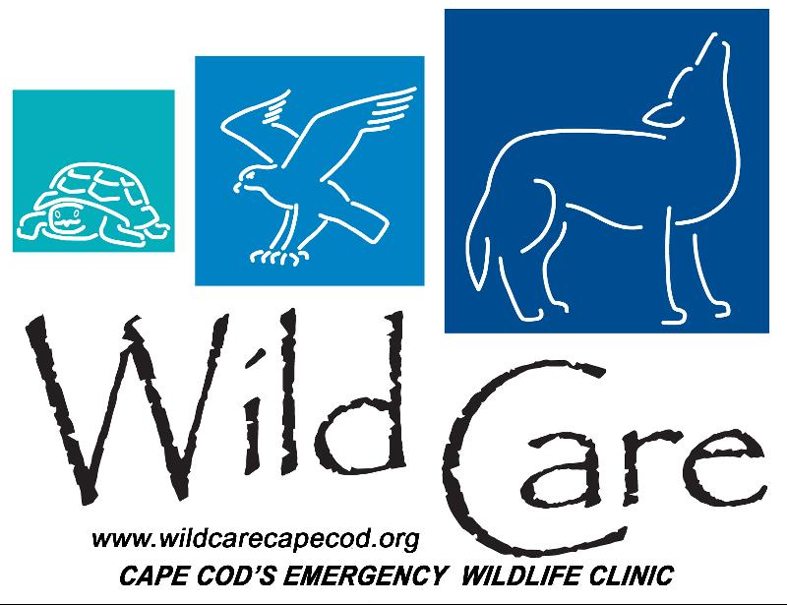

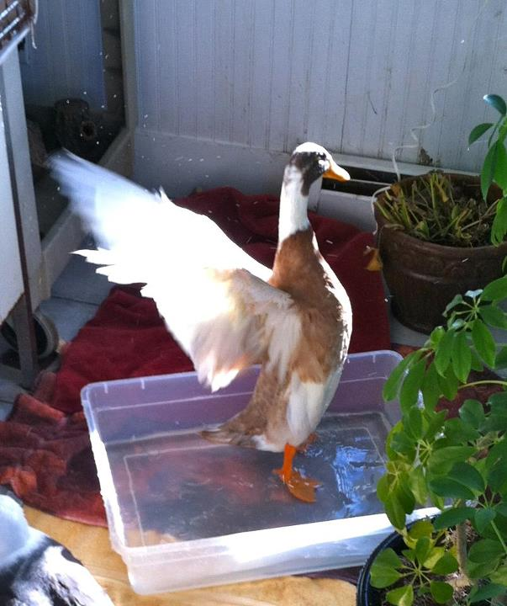
"DUCK TALES"

Wild Care's Monthly E-News

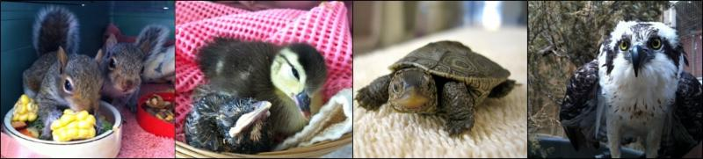

To learn more about Wild Care, visit our web site!
www.wildcarecapecod.org

  A Sticky Situation
  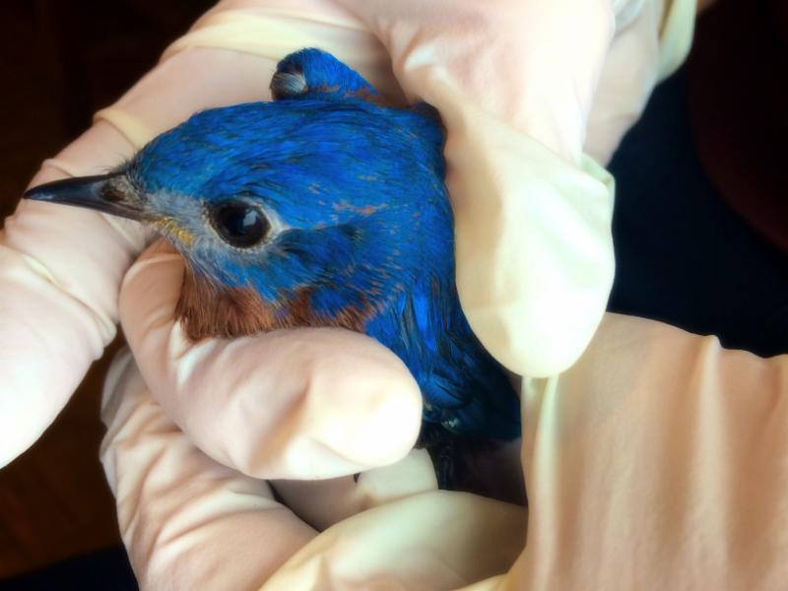
  Photo by: Cristalyn Searles
  A concerned resident from Harwich brought us a male Eastern Bluebird in December whose wing was covered with pine sap. The bird had spread the sap through its feathers by either trying to remove it or through regular preening. Wild Care staff carefully removed the sap with Dawn detergent emulsified with canola oil - which is a very delicate procedure. After several washings the sap was gone and the bird was given antibiotics for its torn skin. The bluebird was a great patient - he ate well and really thrived. He preened consistently and once he was water-proof we moved him to one of our small aviaries. We were happy to see that he was ready to be released just before the new year.
  In December, we had lots of wild bluebirds come to our property, even visiting the aviary while our recuperating bluebird was there. So when we released him we knew he would have lots of bluebird buddies nearby!
  Go Wild This Winter!
  Don't Miss A Wild Winter Night
  March 7th
  Elks Lodge, Eastham
  Join us for a night of fabulous food and amazing live and silent auction items. Tickets $30 in advance or $35 at the door. RSVP now by emailing events@wildcarecapecod.org or calling 774-353-6203.
  Click here for more information.
  The Fate of a Falcon
  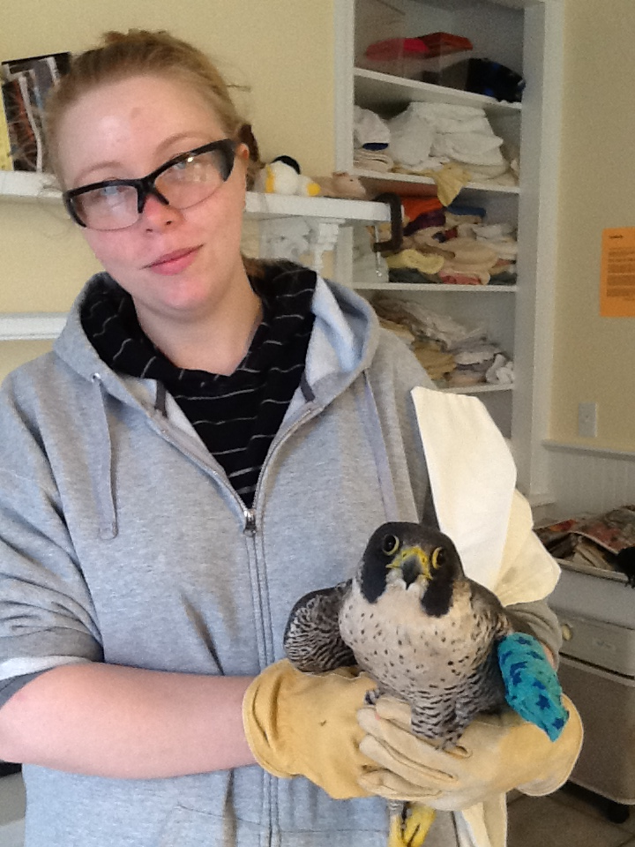
  Wild Care intern Kaylin Lemieux with Peregrine Falcon
  Wild Care was able to assist with the care of an adult Peregrine Falcon that came to us from off-Cape. Wild Care stabilized the bird and splinted the compromised wing. As many of you know, Peregrine's are an endangered species. Protocol for endangered species is to contact Fish and Wildlife and follow their further directions, which we did. The bird was transported up to Tufts Veterinary School where they x-rayed him and discovered he had been shot.
  We are pleased to report that with care from collaborating wildlife organizations, the falcon survived ~ and we want to always remind Wild Care friends to be very conscious about the endangered creatures that share our home.
  Donate Items from our Wish List
  Icy Rescue
  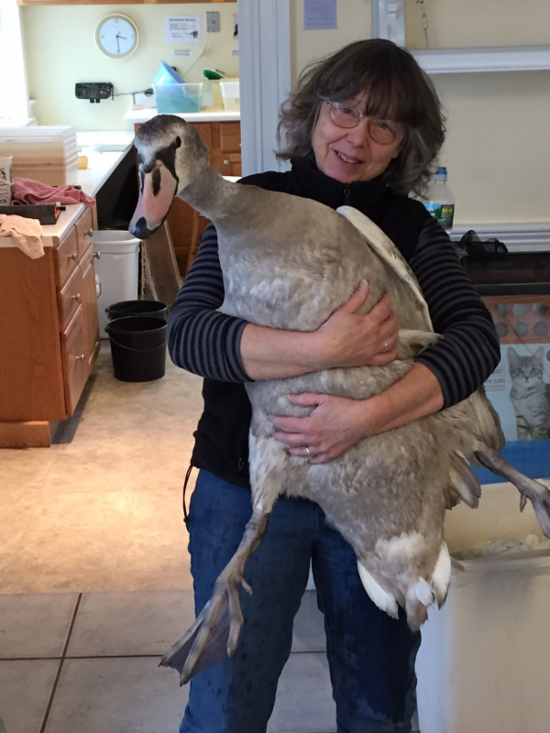
  Jennifer Taylor, Wild Care's Animal Care Coordinator, holds our swan patient.
  You may have seen the story of the brave rescue of a juvenile mute swan from Hinckley's Pond in Harwich earlier this month in the local papers. The Harwich Fire Department was alerted by members of the community that the swan was struggling and suffering on the icy pond, so firefighters crawled out on the ice to bring him safely in. Wild Care volunteer Lee Chase was on site and brought the swan back to the clinic, where, luckily we saw no frostbite, but had to treat his feet for abrasive wounds. With the generosity of many Wild Care supporters we continued his care for a couple of weeks and we were able to release him, healthy again, back to Hinckley's Pond last Friday. Thank you to everyone who helped support his care!
  Click here to see his release, filmed by Eric Williams of the Cape Cod Times.
  Interested in Joining Wild Care's Board of Directors?
  Do you support Wild Care's mission? Do you have a skill or experience that would be valuable to the Wild Care organization? Do you enjoy working within the community to solicit support for Wild Care?
  We are currently searching for candidates for membership on Wild Care's Board of Directors to work on Fundraising, Publicity, Donor Cultivation, Events and more. If you are interested in joining our Board, please write a letter to Cassie Marischen, Board Chairman, at cmarischen@gmail.com. Please describe your interest, background, and what you feel you would contribute to the Board in addition to including your resume. Qualified candidates will be contacted for an interview.
  Stay informed about what's happening at Wild Care.
  Like Us on Facebook!
  Click here to go to our page. See pictures and videos of our animal patients and more!

Wild Care
10 Smith Lane
Eastham, Massachusetts 02642
info@wildcarecapecod.org
508-240-2255

About Wild Care
Since 1994, Wild Care has treated injured, ill and orphaned native wildlife for release back into the wild capable of independent survival, prevented wildlife casualties through public education and counseling, and engaged the community in conservation services through volunteerism.
Wild Care does not charge the public for our services. We accept wildlife regardless of a rescuer's ability to make a donation; and we never compromise quality of care or the dignity of an animal's life for fundraising purposes.

