December 2014 Duck Tales

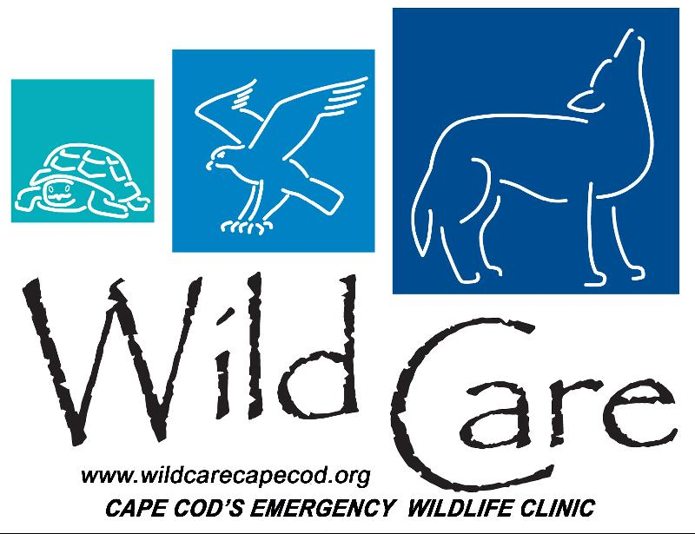

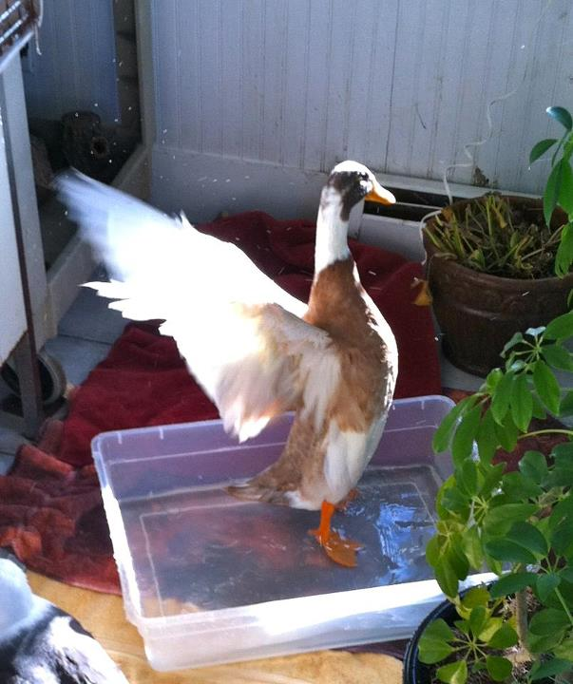
"DUCK TALES"

Wild Care's Monthly E-News

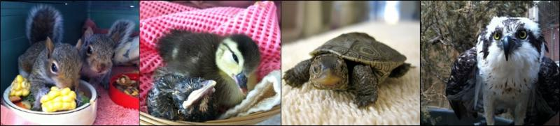

To learn more about Wild Care, visit our web site!
www.wildcarecapecod.org

  Last Minute Shopping?
  Looking for a holiday gift for that special someone? Do they love animals? Why not give them some holiday cheer from Wild Care!
  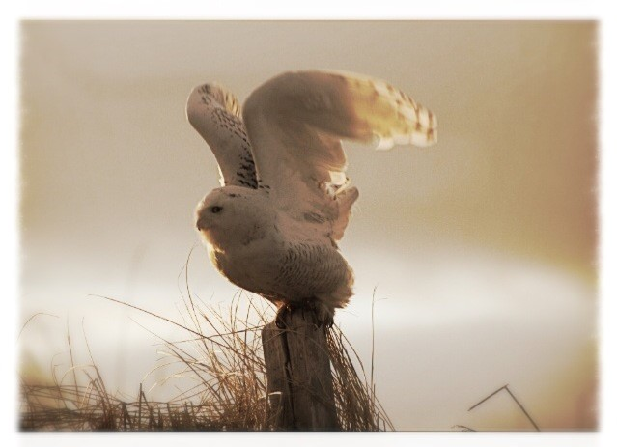
  For a donation of $25, you will receive one of our new cards, featuring this beautiful snowy owl photo taken last winter by Wild Care Board member Judy Bullard, that you can present to a loved one. It lets them know that you have donated in their honor to support Wild Care's work rescuing and rehabilitating wild animals on Cape Cod. (We also have other cards available for a donation of $10.) Call us at 508-240-2255 or 774-353-6203 to get yours in time for the holidays!
  It is Sea Bird Season
  With the winter comes the storms, and with the storms come the Sea Birds! Traditionally, Wild Care sees increased numbers of injured and stranded sea birds in the winter months, and with our Sea Bird Therapy Pool project nearing completion, we will be ready for our cold weather guests. Already we have had several come to our clinic, including a razorbill and a few Herring gulls. One of the herring gulls was rescued in Eastham in late November after a Nor'Easter brought wind and rains across the Cape. The rescuer thought the gull's wing was broken, but on examination, our animal care team discovered that it was actually twisted back into his body and he couldn't unfurl it on his own. After gently straightening the wing, we moved him to the aviary. He quickly began eating and gaining strength and we were able to release him on December 8th.
  Want to help a
  Sea Bird this winter?
  Click here to donate!
  A Year of Generosity!
  Wild Care wants to thank everyone who supported the work we do to rescue, rehabilitate and release wild animals on Cape Cod. 2014 saw so many of you donating time, energy, goods and funds to help keep our clinic open every day, and we truly appreciate it.
  We'd like to highlight some of the companies and individuals who sponsored our events throughout the year, both with in-kind donations and with direct funding. We couldn't have had such success in celebrating with our community without their help!
  Arnold's Lobster & Clam Bar
  Bird Watcher's General Store
  Cape Cod Five
  Cape Cod Wealth Strategies
  Derbyfield Kennel
  Terry & Gail Eldredge
  Farland Provisions
  Front Street Restaurant
  George's Fish Market
  Gordon Grimes/Sysco Foods
  J. McLaughlin Store
  Kinlin Grover
  Moby Dick's Restaurant
  Napi's Restaurant
  Nauset Disposal
  Orleans Camera
  Sherri Pedane
  Pennie's Liquors
  Pine Tree Nursery
  Power Yoga of Cape Cod
  The Provincetown Hotel At Gabriel's
  Reinhart Paint
  Seamen's Bank
  Van Rensselaer's Restaurant
  Veterinary Associates of Cape Cod
  Donate Items from our Wish List
  HAPPY HOLIDAYS
  from all of us at
  Wild Care!
  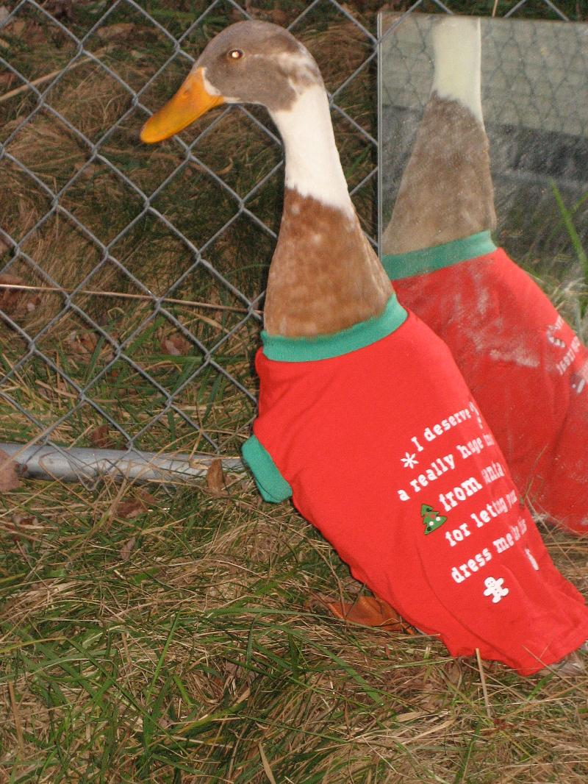
  Home for the Holidays
  Happily, we were able to release our long-term possum patient earlier this month. After steadily improving after his jaw surgery, he was ready to be returned to the wild by our wonderful volunteer Roz Goldstein. As you can see in this photo, (being held by Wild Care staff Wildlife Rehabilitator Niki Howes) he was vocal about his release!
  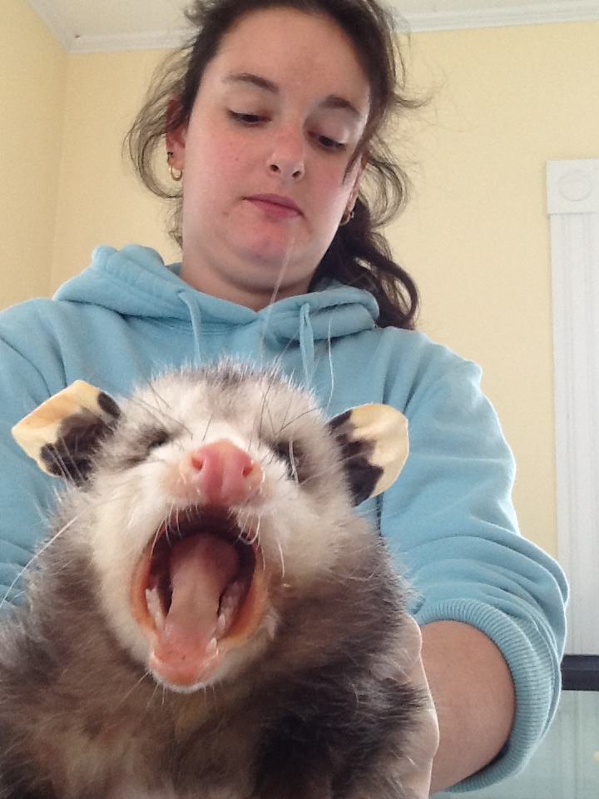
  Wildlife Rehabilitator Niki Howes
  Window Strikes
  Unfortunately, many of us have had this happen ~ one of our feathered friends flies into a window at our home or office and appears to be seriously injured. It is possible that the bird is simply stunned by the impact, and that he will regroup and be able to fly off on his own. If it appears that isn't the case - give us a call at Wild Care at 508-240-2255 and we can advise you what to do next. It might make sense to bring the bird into our clinic. We've had a couple of window strike victims at Wild Care this month - a Hairy Woodpecker from Harwich which we released the next day and a Mourning Dove who stayed a bit longer (to gain some weight.)
  We can also give you ideas on ways to help prevent these accidents ~ it is most important to take away the reflection on the outside of the window. Here is a link for some good ideas: http://www.humanesociety.org/animals/ resources/tips/bird_safe_windows.html. We want to help you help the wild animals who visit your yard and delight you all year long!

Wild Care
10 Smith Lane
Eastham, Massachusetts 02642
info@wildcarecapecod.org
508-240-2255

About Wild Care
Since 1994, Wild Care has treated injured, ill and orphaned native wildlife for release back into the wild capable of independent survival, prevented wildlife casualties through public education and counseling, and engaged the community in conservation services through volunteerism.
Wild Care does not charge the public for our services. We accept wildlife regardless of a rescuer's ability to make a donation; and we never compromise quality of care or the dignity of an animal's life for fundraising purposes.

